LAB 7 Assignment

Shuaiyu Liang (sl5352)

Tuesday 17th November, 2015

7-5 Plot of frequency response of the system.

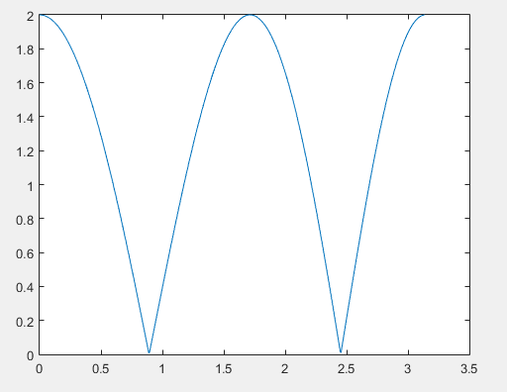

System is built by two cascaded second order all pass filter. With parameters as

b = [x^2 2\*x\*cos(theta) 1] and a = flip(b) where theta is desired notch frequency.

Single transfer function goes like:

